The Title is typed in Times New Roman, 14 pt, capitalize each Word, Maximum 12 Words.
First Author^{1*}, Second Author², Third Author³

^{1,2}Institution/Affiliation (if Affiliation is the same)
Institution Address, Country

³Institution/Affiliation (if Affiliation is different, separated)
Institution Address, Country

e-mail: ¹xxxx@xxxx.xxx, ²xxxx@xxxx.xxx, ³e-mail: xxxx@xxxx.xxx

(*) Corresponding Author

Article Info: Received: 00-00-0000 | Revised : 00-00-0000 | Accepted : 00-00-0000

Abstracts - The paper's abstract templates guide writing papers for journal publications, Bina Sarana Informatika. The paper writers must follow the instructions given in this paper. Abstract is restricted to 100-250 words in the English Language (in italics), should not contain equations, pictures, or tables. The letter size for abstract, keywords, and body papers is 10 points using Times New Roman font. The abstract contains the prologue of the raised problem, the proposed method and the desired results (hypothesis). The number of pages in the manuscript is at least 6 pages, a maximum of 10 pages, with an even number of pages using A4 paper size with 1 (single) spacing.

Keywords : 3 - 5 words or phrases

INTRODUCTION

The article has never been published in any other media and contains no elements of plagiarism. A plagiarism-free statement can be included in a document signed by the author(s) and uploaded as a supplementary file (step 4) or by attaching the plagiarism check results.
The manuscript format is single column, using A4 paper size (21 × 29.7 cm) with margins: left and top 3 cm, right and bottom 2 cm. The manuscript is written in Microsoft Word, single-spaced, Times New Roman 10 pt, with a minimum length of 6 pages and a maximum of 10 pages. The total number of pages of each volume must be Odd (7 or 9 pages) for Issue 1 (January) and Even (6, 8, or 10 pages) for Issue 2 (July). Paragraph settings: 10 pt spacing after, without First Line Indent.
The article title must describe the content using the fewest possible words. Avoid using phrases that make the Title unnecessarily long, such as "A Study of…," "An Investigation on…," "Implementation of…," "Observation on…," "The Effect of…," "Analysis of…," "Design of…," etc. Article discoverability depends on the accuracy of the Title; keywords also assist in search referencing.
The Title should contain a maximum of 10 words in English per the DIKTI accreditation rules.
The Introduction should clearly describe the background, a clear statement of the problem, relevant literature related to the subject, the proposed approach or solution, and the novelty value of the research, containing innovation.(Birtha, Arifudzaki; Soemantri, Maman; Abdian, 2010)
References and citations must follow APA Style 7th edition. Foreign terms should be written in italics. The manuscript should be organized into the following sections: Introduction – Research Method/Algorithm (optional) – Results and Discussion – Conclusion. (Liza & Yupinti, 2012)
The literature review may be included in the "Introduction" section to explain the differences between the research and other articles and show that the work is the latest innovation. (Han & Kamber, 2006)
If the research has high originality, proposing a new method or algorithm, an additional section after the "Introduction" and before the "Research Method" can be added to describe the proposed method or algorithm briefly. The Introduction section may also include supporting theories of the proposed method to solve a problem and/or the development of the method, based on clear references (books, journals, proceedings, and other scientific articles).

1. Manuscript Layout
The abstract must be written in 1 paragraph, with justified alignment. The manuscript from the Introduction to the References should be formatted in a single-column layout. Titles of tables and figures should use sequential numbering, e.g., Table 1, Table 2, etc., or Figure 1, Figure 2, etc. The table format should use vertical and horizontal lines for each data entry (Marcoulides, 2005). An example can be seen in Table 1.

The table text should be written in Times New Roman, size 10, and all foreign terms must be italicized.
Table 1. Table Title
No | Gap | Score | Description
1 | 0 | 5 | No gap (Competence matches the required level)
2 | 1 | 4,5 | Individual competence exceeds the required level by 1 level
3 | -1 | 4 | Individual competence is 1 level below the required level
Source: xxxxx (9999) (if research result, the source may be written as “Research Result (Year)”)

The format of figures should follow the example below:

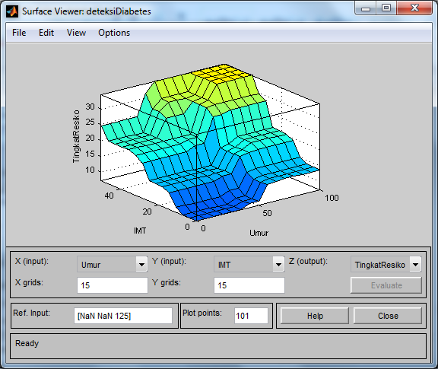
Source: xxxxx (9999) (if research result, the source may be written as “Research Result (Year)”)

Figure 1. Figure Name

* If a figure or table is difficult to place within the manuscript, it may be placed on the last page while still providing the figure name or table title.

2. Equations and Symbols
Equations must be written in italic and numbered in parentheses. Equation citations should be in the form “equation (2)”. All symbols must be defined within the body of the manuscript.

Below is an example of an equation along with the symbols used:

$Similarity \left(p,q\right)= \frac{\sum_{i=1}^{n}{}f\left(pi,qi\right) X wi}{wi}$ (1) $Similarity \left(p,q\right)= \frac{\sum_{i=1}^{n}{}f\left(pi,qi\right) X wi}{wi}$
Description of symbols:
p = New cases
q = Cases stored in the database
etc.

3. Numbering
Use numbering consistent with the numbering format in Microsoft Word. For item listings, use a colon without a space. The numbering sequence should follow this order:
Nomor item berurutan, dimulai dari penyebutan dengan angka sampai dengan huruf:
  - Main items (1, 2, 3, …)
  - Sub item – numbered with lowercase letters (a, b, c, …)
  - Sub sub item – numbered with Arabic numerals followed by a parenthesis: 1), 2), and so on

Header : Contains the journal name, volume, issue number, ISSN, and E-ISSN.
Footer : Contains the journal website link and page numbering positioned on the right-hand side.

RESEARCH METHOD

Explain the research chronology, including the research design, research procedures (in the form of an algorithm, pseudocode, or others), and how to conduct testing and data acquisition. The description of the research program should be supported by references so that the explanation can be scientifically accepted.

RESULTS AND DISCUSSION

This section presents the research findings along with a comprehensive discussion. The results can be presented in figures, graphs, tables, and other forms to facilitate the reader's understanding. This section should emphasize the novelty value of the research, containing innovation and its implications. The discussion may be organized into several sub-sections.

1. Sub Section 1
xx

2. Sub Section 2
yy

CONCLUSION

Please state that the expectations outlined in the Introduction are ultimately achieved in the Results and Discussion, ensuring their compatibility. In addition, prospects for further development of the research findings and potential applications for future studies may be included. Avoid statistical data in this section and also present recommendations for future research based on relevant sources.

REFERENCES

The primary references should be international and national journals or books with an ISBN. All references must be the most relevant and up-to-date sources. References must be written in APA Style 7th Edition. Each citation should be listed in ascending order (A–Z) and not grouped by type (book, journal, etc.). References from websites/URLs should come from trusted sources. References must be managed using Mendeley Desktop or another reference management software. All references cited in the manuscript must appear in the reference list. The reference list should contain at least 15 sources, with 80% being primary references (scientific journals, conference proceedings, reference books, undergraduate theses, master's theses, or dissertations), consisting of 5 international and 10 national articles, published within the last 5 years. The similarity index must be a maximum of 20% using Turnitin or similar tools.

Example of Reference:

Birtha, Arifudzaki; Soemantri, Maman; Abdian, F. (2010). Application of an inventory information system for a marine export company based on the web. Transmisi, 12(1), 1.
Han, J., & Kamber, M. (2006). Data Mining: Concepts and Techniques. Soft Computing (Vol. 54). https://doi.org/10.1007/978-3-642-19721-5
Liza, Y., & Yupinti. (2012). Inventory information system at PT Surya Nusa Bhaktindo Bengkulu. Media Infotama, 8(1), 90–117.
Marcoulides, G. A. (2005). Discovering Knowledge in Data: an Introduction to Data Mining: Discovering Knowledge in Data: An Introduction to Data Mining. Journal of the American Statistical Association (Vol. 100). https://doi.org/10.1198/jasa.2005.s61

